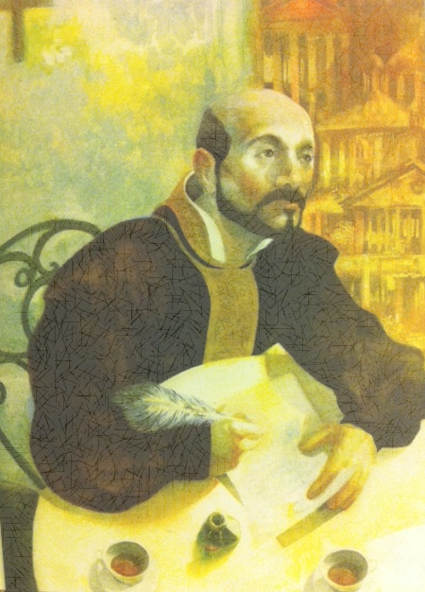
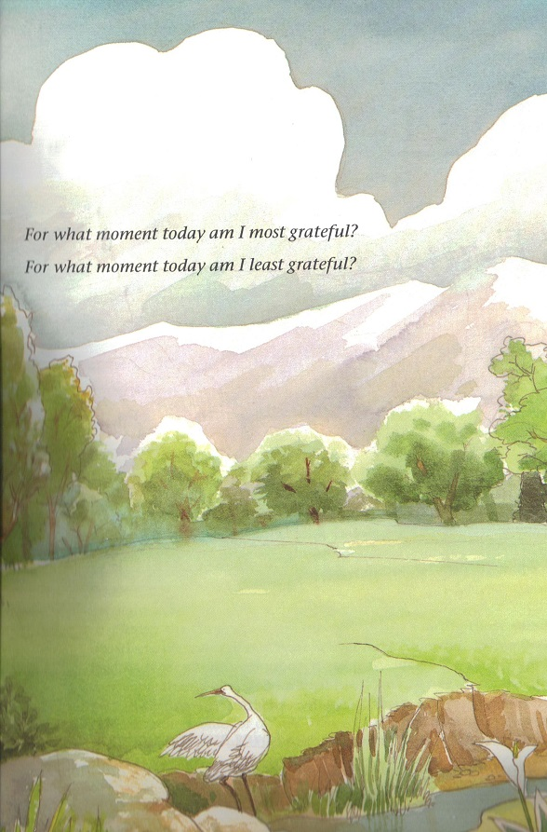
The Examen

of St Ignatius of Loyola
1. Gratitude – I give thanks for the gift of life and the goodness of this particular day.
2. Help – I ask for the Holy Spirit’s help to see this day with God’s eyes not just my own.
3. Review – I review my day hour by hour, to see how God is working in my life, and the movements that are not of God. I review the choices I have made in response to both.
4. Response – I respond to what I felt or learnt, with repentance and gratitude.
5. Resolve – I look to the next day and ask for the graces I will need to live it well.

The Examen
of St Ignatius of Loyola

1. Gratitude – I give thanks for the gift of life and the goodness of this particular day.
2. Help – I ask for the Holy Spirit’s help to see this day with God’s eyes not just my own.
3. Review – I review my day hour by hour, to see how God is working in my life, and the movements that are not of God. I review the choices I have made in response to both.
4. Response – I respond to what I felt or learnt, with repentance and gratitude.
5. Resolve – I look to the next day and ask for the graces I will need to live it well.

