Desolation

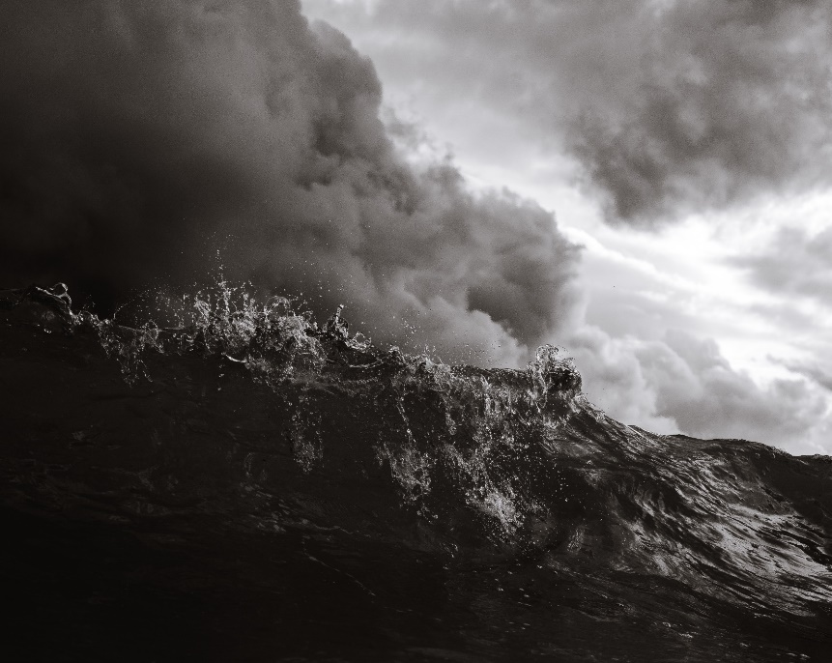

This exercise should take at least twenty minutes.

- Invite God to be the One who guides this time of prayer.
- Think of an experience so far this year that may have been spiritual desolation and do the “attention to experience” exercise, with this experience:
- Describe what happened;
- Name the (thoughts and) feelings you had at the beginning, middle, and end of the experience;
- Looking closely at one of those feelings within yourself, try to describe that feeling in more detail:
  - See if you can name other feelings that are part of the feeling you’re describing, e.g. if you look more closely at the feeling of disappointment, you might find that there’s sadness in it, as well as an element of surprise.
  - Do you feel this emotion in your body anywhere? How? What happens?
  - Are there any images or memories that come into your mind as you pay attention to what it felt like?
  - Make sure that you don’t leave out anything that seems “bad” or unpleasant, or anything that doesn’t seem to make sense.
- Also name the thoughts that were in your mind during the experience. Particularly look out for things like:
- “I should have…”, “I shouldn’t have…”
- “It’s always going to be like this”
- “I’m a bad person”
- “God isn’t looking after me”
If at any point in this process you’re stuck, and just can’t go any further, for any reason, stop. Ask instead what are the feelings you’re experiencing now, in being stuck. What is it like for you, to find yourself unable to do this? If you can succeed in naming and describing this experience, that might be enough for today!
- Compare the experience you’ve been paying attention to with rule 4: was it spiritual desolation?
- If so, what were you tempted by or inclined towards, that could be described as “low and earthly”, or sinful? What were you tempted away from, that is good and Godly?
- Can you name the false message, which you believed or half-believed, that led into the desolation?
- How did you respond (act, behave) in the desolation? Did you follow rules 5-8, or not? (Be gentle with yourself if you didn’t—it takes a long time for these things to become habits. Just ask for God’s forgiveness and for the help and strength to do better next time).
- Can you see any benefit that came to you from the desolation, and/or what benefit has come from this exercise in attending to the experience of this desolation?

Self-Defence



This exercise should take at least fifteen minutes.

- Ask God to guide and inspire and be with you in this exercise.
- Choose an experience of sin that has happened this year sometime.
- Write down, in as much detail as possible, what happened during that experience. Describe it impartially, avoiding interpretations and judgments.
- Focus on where the enemy might have taken advantage of your weak points. Where did you fail to respond to God or others in love? Why? What was happening for you at the time?
- Try and notice the train of thoughts or feelings you had, from the beginning of the experience. Even write them down, describing how you felt and why you decided the way you did in the end.
- What was the strongest feeling driving your actions? See if you can describe what that feeling was like for you. Describing where and how you feel the emotion in your body or what the feeling makes you want to do can be helpful. It can also help to use images.
- Can you see rule 12 at play here – was the temptation so strong and insistent that eventually you just gave in? If so, ask God for the grace to stand firm next time.
- Can you see a pattern of this happening regularly in your life? Is this a weak point that needs strengthening, as in rule 14? If so, ask God for inspiration as to how you might best begin to work on it.
- Is/was the situation one that you feel small about talking to anyone else about? Would it help, even if it is humiliating or very hard to do, to talk to someone about this situation or pattern of behaviour? If so, ask God who you might talk to and how and when.
- Briefly talk to God about all this, imagining him as a caring friend who’s interested in your experience.
- Make sure you tell God that you’re sorry for your sins, and thanking Him for His loving forgiveness, knowing that, in His mercy and compassion, He is not holding on to them.
- Finish with an Our Father.

